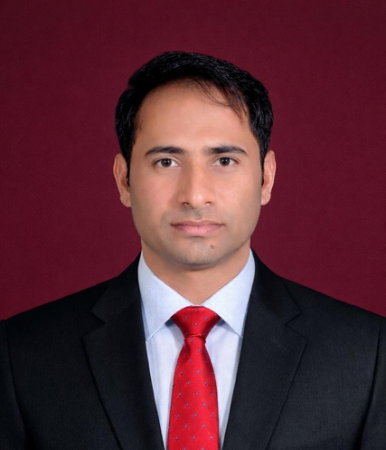

Dr Muhammad Noman
MPHIL PHD CHPE MPH
Managing Director Research Cell
Faisalabad Cancer Center, Faisal Hospital Faisalabad
Chief Executive
Sir James Lyall Oncology
Faisalabad International Hospital
East Canal Road, Faisalabad

Dr. Muhammad Noman is a Biochemist and Molecular Biologist specializing in Human Genetics, Molecular Biology, Hereditary Disorders and Cancer Genetics. His research experience includes Genetic Variant analysis, Molecular Diagnostics, and Cancer Genetic Profiling, with collaborations involving national and international research institutions. He has authored peer-reviewed scientific publications and scholarly book chapters. His research interests include Cancer Genetics, Precision Medicine, and Translational Oncology, with a commitment to scientific integrity and excellence in scholarly publishing.

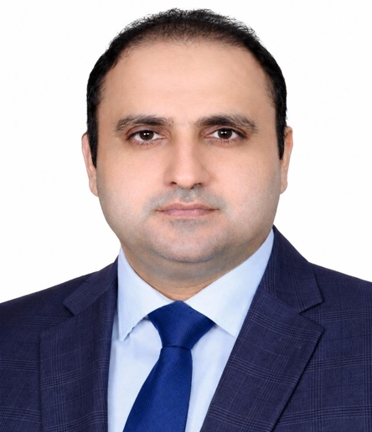

Dr. Muhammad Tahir Bashir
MBBS, FCPS, FACP, MRCPS (Glasg), MCPS (Health Professions Education)
Associate Professor of Oncology
Head, Department of Oncology
Faisalabad Medical University, Faisalabad, Pakistan, and Affiliated Hospitals
Director, Office of Research, Innovation and Commercialization (ORIC)
Faisalabad Medical University, Faisalabad, Pakistan
Dr. Muhammad Tahir Bashir is an Associate Professor of Oncology and Director of the Office of Research, Innovation and Commercialization (ORIC) at Faisalabad Medical University, Pakistan. His professional expertise encompasses clinical oncology, medical education, academic leadership, and research management. His research interests include cancer prevention, early detection, clinical and translational oncology, evidence-based healthcare, and improving patient outcomes. He is committed to advancing cancer research, fostering interdisciplinary collaboration, and translating scientific evidence into improved clinical practice and healthcare delivery.

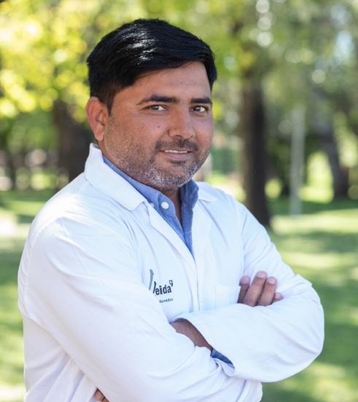
Dr Sajid Hussain
PHD Biological Sciences
Post-Doctoral Research Fellow
Research Group of Cancer Biomarkers,
Biomedical Research Institute of Lleida (IRBLleida),
Av. Alcalde Rovira Roure, 80, 25198 Lleida, Spain

Sajid Hussain’s expertise encompasses cancer biology, molecular and cellular biology, molecular imaging, and drug-delivery research. His primary research focus is triple-negative breast cancer, particularly MYC- and BRD4-associated oncogenic signaling, epigenetic regulation, cancer-cell metabolism, apoptosis, and mechanisms of therapeutic response. Sajid Hussain has experience in molecular and cellular assays, protein analysis, functional studies, fluorescence microscopy, two-photon imaging, and quantitative image analysis. His research interests include targeted cancer therapy, identification of molecular vulnerabilities in cancer cells, and translational approaches to improve therapeutic strategies. He is also interested in chemical biology, fluorescent-probe development, intracellular organelle imaging, and the application of molecular imaging tools to investigate cancer-associated cellular processes. His broader expertise includes drug mechanisms, oral drug absorption, intestinal mucus biology, epithelial transport, and interactions between absorption enhancers and biological barriers. Sajid Hussain is experienced in experimental design, data analysis and interpretation, scientific manuscript preparation, grant development, interdisciplinary collaboration, laboratory coordination, and mentoring junior researchers.

Dr. Shehbaz Ali
Associate Professor
Affiliation: Department of Biotechnology, International Institute of Science, Arts and Technology, Gujranwala Pakistan
Country: Pakistan
Expertise: Synthetic Biology; Molecular Biology; Microbial Biotechnology; Bioenergy and Bioprocess Engineering; CRISPR-Cas Genome Editing; Metabolic Engineering; Lignin Valorization

